Lab 5
- Open the adobe illustrator and go to print & select artboards as 2
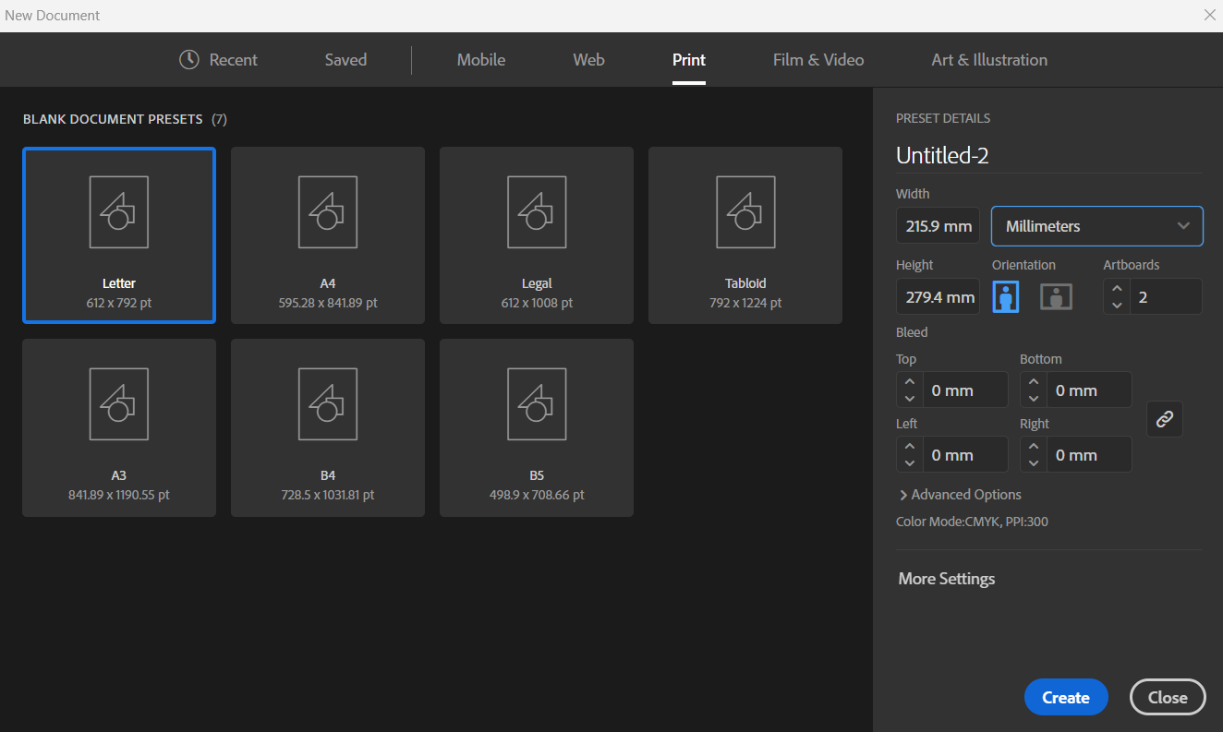
Now you get 2 side of the id card

- Now add color to both sides, using fill but first select the rectangle tool on the left and drag from top left corner to right bottom corner and then use the fill. Do this on both sides
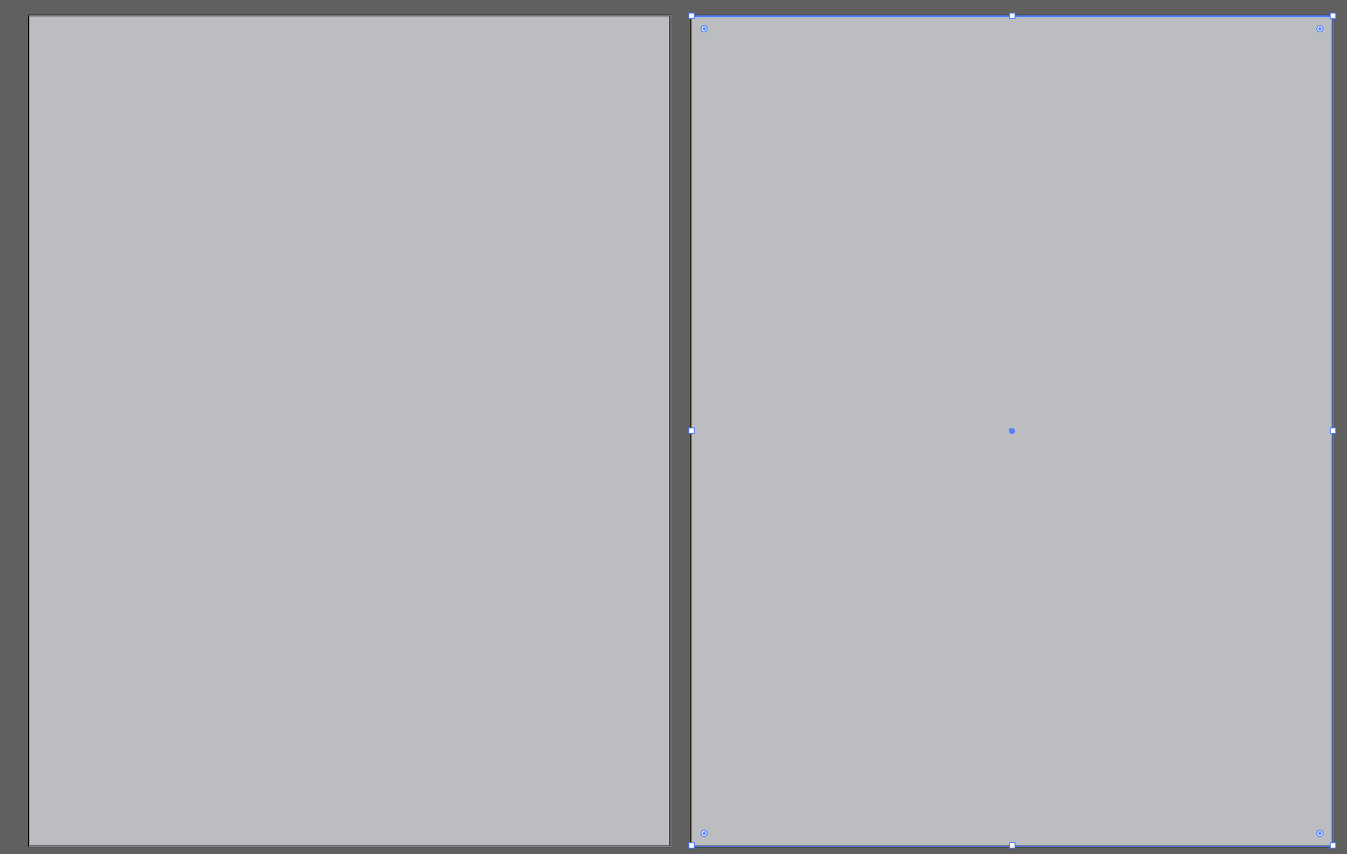
You can add increase the opacity too. It is located on the right near fill
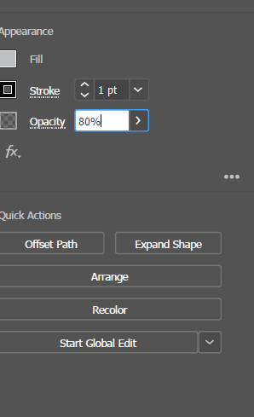

- Now add another rectangle just like shown on the figure

- Now change the shape of the recent rectangle

Now add text on the curved semi oval/circle about your college and add other info too.
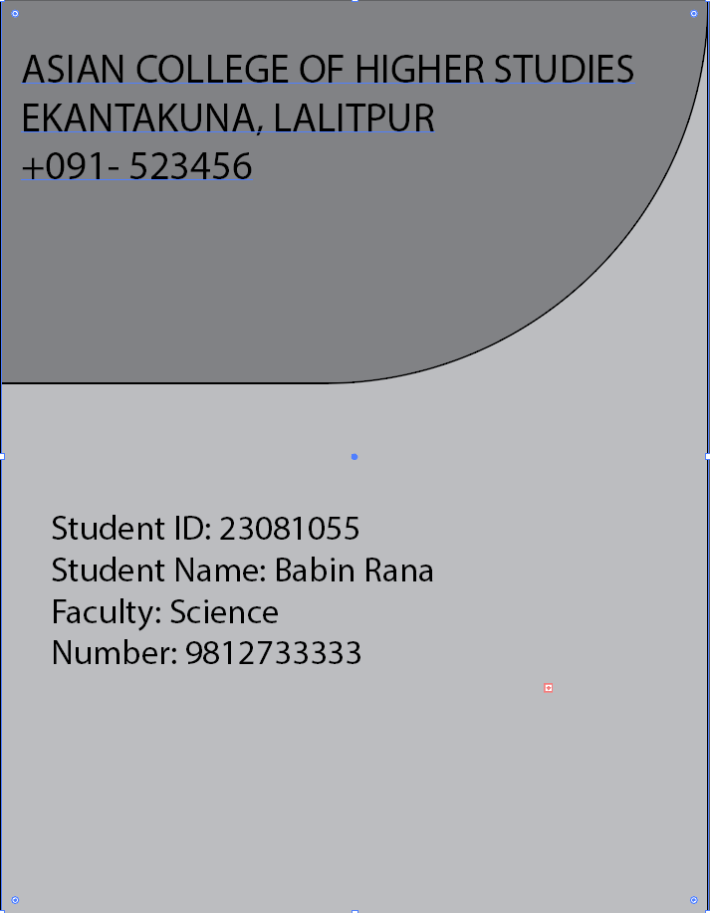
Now add a photo, first add a circle and then drag a photo on top of it. After that select the circle a right click , go to arrange and bring it to the front. After that select both photo and circle then right click and do the clipping option.
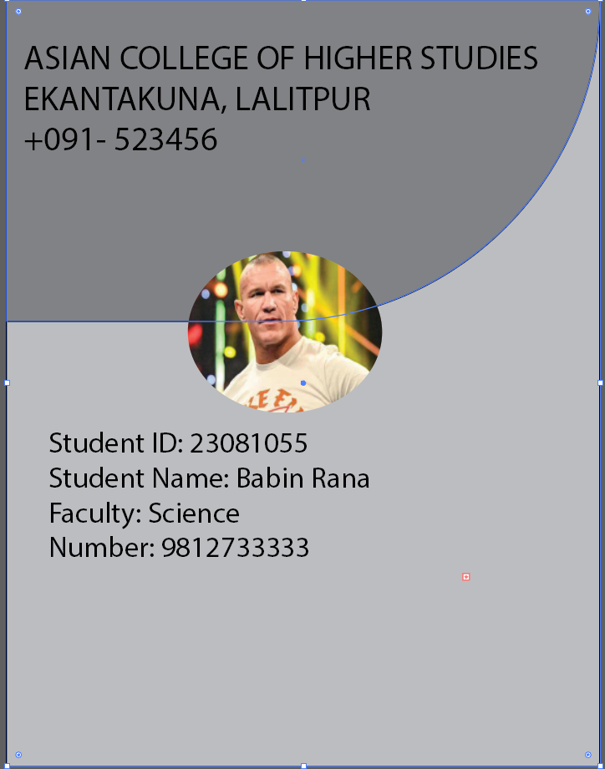
Now use the pen tool to create some shapes and put a logo of your college too
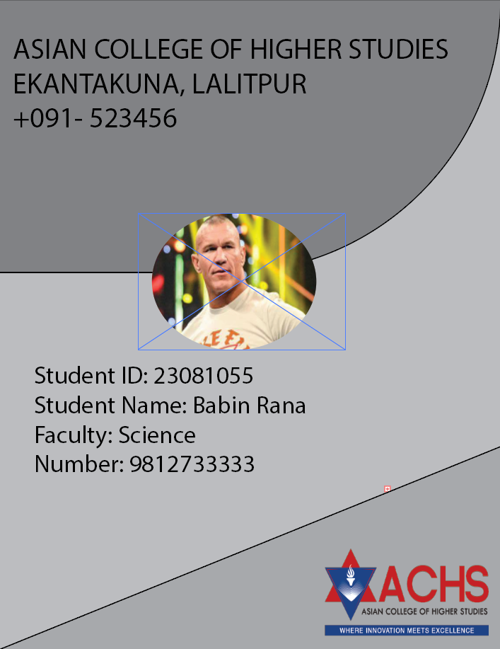
Now use different tools to do create the back of the id card
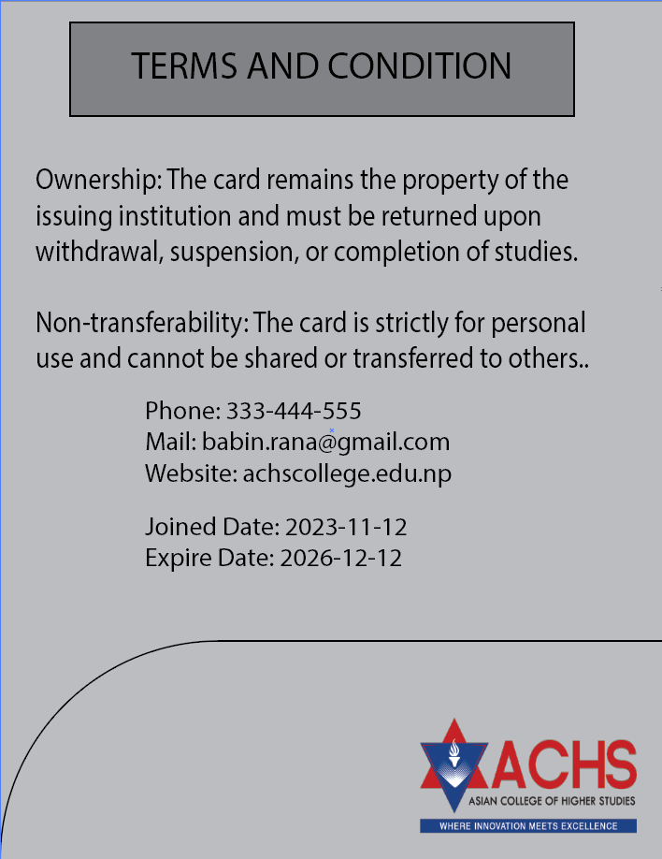

Now your id card is ready
